Hollywood in your hand.

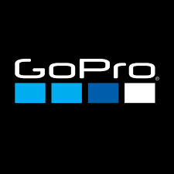

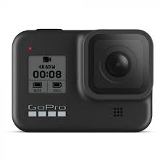
Summary:

- What is the Product?
- How are they selling it?
- How is it priced?
- What promotions are they using?
- What datasets do you think you will need to build these services?
- How frequently will data change?
- How would you store these datasets?
- How is the company tracking visitors?

GoPro, Inc. is an American technology company founded in 2002 by Nick Woodman. It manufactures action cameras and develops its own mobile apps and video-editing software. Founded as Woodman Labs, Inc, the company eventually focused on the connected sports genre, developing its line of action cameras and, later, video editing software. It is based in San Mateo, California.

- What are the Products?

Cameras:

Hero10 Black Creator Edition:

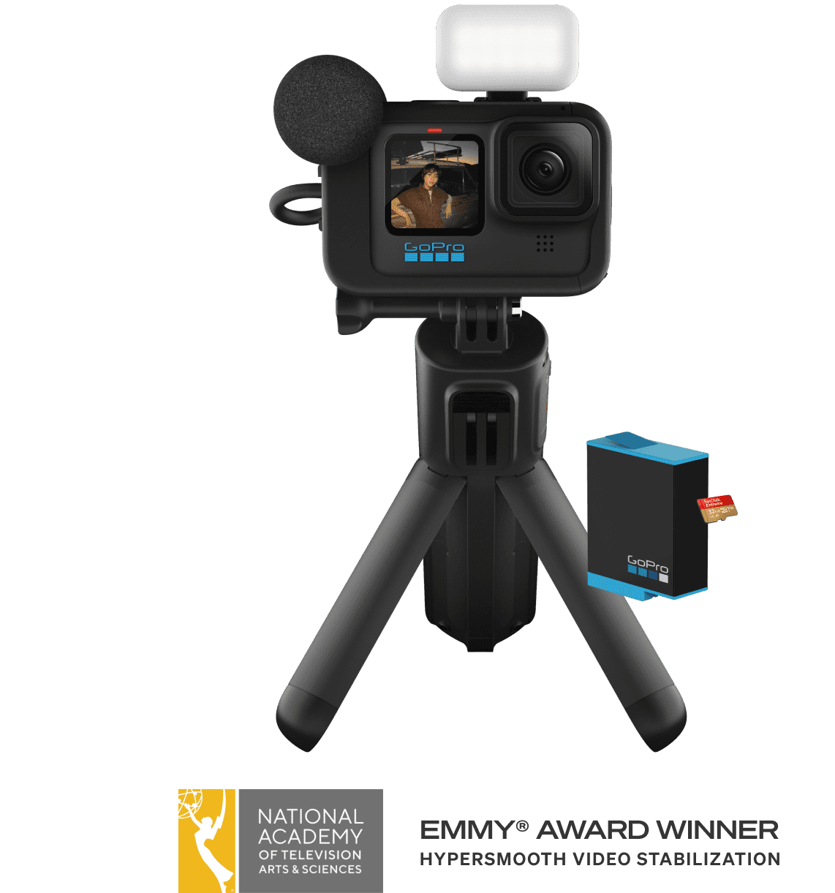
The HERO10 Black Creator Edition is an all-in-one content capturing powerhouse that makes vlogging, filmmaking and live streaming easier than ever. This complete system features pro-quality 5.3K video, Emmy® award-winning Hyper Smooth 4.0 video stabilization, enhanced audio, powerful LED lighting and 4 hours of 4K recording per charge.

Hero8 Black:
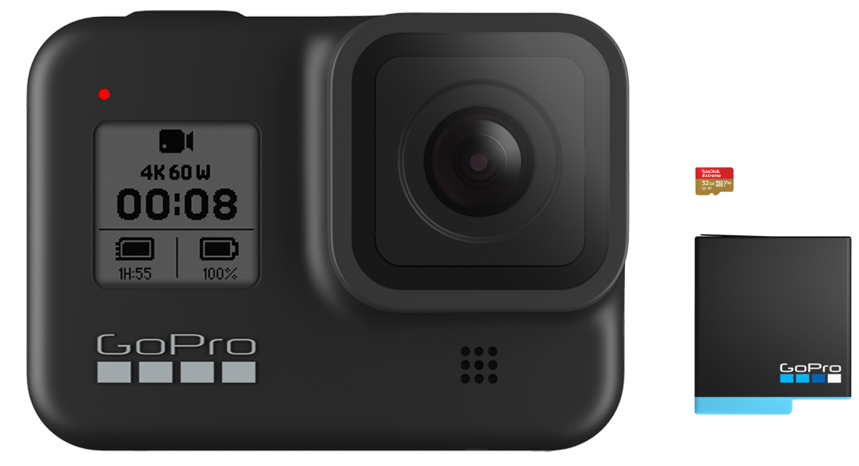

Amazing Hyper Smooth 2.0 video stabilization combines with a tough waterproof design to make this a super versatile action camera. Capture killer 4K videos 12MP photos and customize your setup with mods.

Accessories:
Volta Tripod: 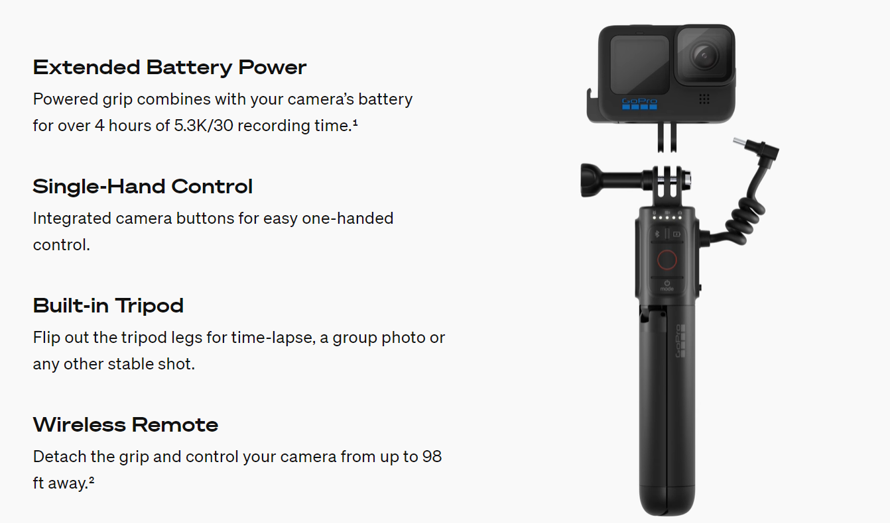

HERO10 & HERO9 Protective Housing + Waterproof

Product Details
- Protects your HERO10 Black & HERO9 Black from mud, dirt and debris during extreme activities
- Front LCD screen remains accessible for viewing
- Waterproof down to 196ft (60m)—perfect for deep-water diving
- Includes a skeleton backdoor for improved audio capture1 and easy access to the camera’s touch screen
- A flat glass lens makes for sharp, high-quality images above and below water
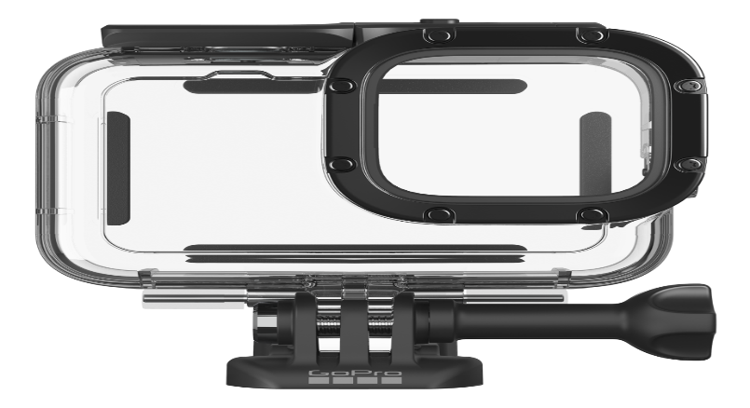

- How are they selling it?

Online Website and Authorised sellers.
The website is https://gopro.com/en/us/
All the products are delivered within the time period of 10-14 business days.
GoPro’s success is that their products offer users the chance to let others see their experiences at the height of the action from their point of view. In the past, this was an expensive, uncomfortable, and nigh-impossible feat to achieve (imagine strapping a 5kg camera onto your head and going skiing!)

It is no coincidence that the success of GoPro correlates to the boom in internet usage over the last decade or so. The number of platforms on which users can share their videos has increased, along with growth in users across the board.

- How is it priced?
The GoPro products will cost between
The price is based on the video resolution, photo resolution and display quality. Each product as different video and photo resolutions which makes variations in the price.

Hero10 Black Creator Edition: $549-$849
Hero8 Black: $280-$380
Volta Tripod: $130

HERO10 & HERO9 Protective Housing + Waterproof:$50

- What Promotions are they using?

GoPro's social media-based marketing strategy attracts a variety of consumers Segmenting their consumers based on psychographics, they can promote their product on a wide array of social media. From thrill seekers to families GoPro will have a camera to fit the consumer's needs. GoPro's Social media marketing enables the company to promote the quality of the product, communicate with the consumer and market to potential new consumers.
- What datasets do you think you will need to build these services?

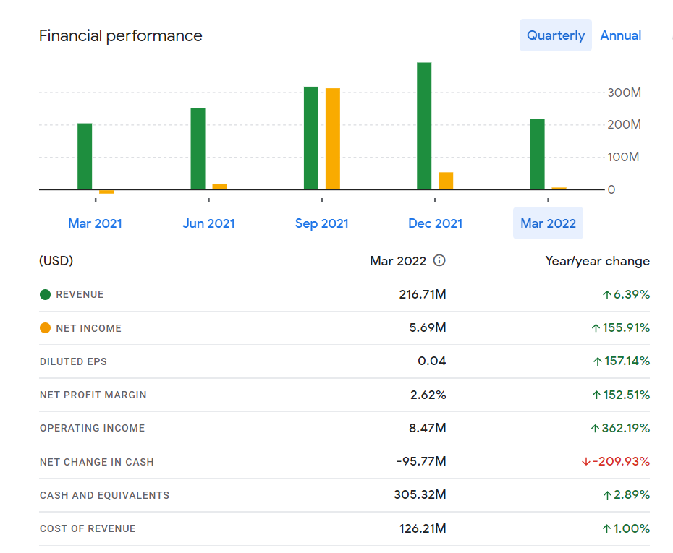

a.)How frequently will data change?

GoPro has opened up a niche market in camera technology.
